**PROJECT PROPOSAL**

## AUTHORS

**RACHEAL KAVUU MAILU(SCT121-0713/2023)**

**&**

**STEPHEN KAMAU (SCT121-0714/2023)**

*A proposal submitted to the Department of Information Technology in the School of Computing and Information Technology in partial fulfillment of the*

*requirements for the award of a Diploma in Information Technology, Jomo Kenyatta University of Agriculture and Technology.*

*2025*

## DECLARATION

This proposal is my original work and has not been presented for a degree in any other university.

Signature: _____________________________

Name: Racheal Mailu

Date: _____________________________

This proposal is my original work and has not been presented for a degree in any other university.

Signature: _____________________________

Name: Stephen Kamau

Date: _____________________________

This proposal has been submitted for examination with my approval as University Supervisor.

Signature: _____________________________

Name: Dr Dennis Kaburu

Date: _____________________________

Contents

AUTHORS 1

DECLARATION 2

1.4 Objectives 8

1.1.4Justification 8

1.1.5 SOFTWARE DEVELOPMENT METHODOLOGY 9

REFERENCES 16

**ABSTRACT**

Top of Form

This proposal presents the design of a Hotel Management System for Hotel Lillies in Juja. The current hotel operations face challenges in efficiently handling customer bookings, menu viewing, and event scheduling, especially for customers who wish to plan or inquire remotely. The proposed system will feature a centralized online platform with an integrated chatbot that enables customers to interact with the hotel via the website. Through the chatbot, customers can view menus and prices, make bookings for dinners or events, reserve rooms, and check available services and packages. This solution aims to improve customer convenience, reduce booking errors, and enhance the hotel's operational efficiency. The Iterative SDLC methodology will be used to ensure that the system is refined based on continuous feedback from both customers and hotel staff.

Bottom of Form

**1.0 INTRODUCTION**

**1.1.1 Background**

Hotel Lillies, located in Juja, offers a variety of services including accommodation, dining, event hosting, and leisure facilities. Despite its services, customers currently have limited options to make reservations or view services online. Bookings are mostly handled manually or through phone calls, which can lead to delays, errors, and missed opportunities to attract new clients. A modern hotel management platform with a chatbot interface will make it possible for customers to instantly get information and make reservations at any time. The hotel is situated along the Thika Superhighway in Juja, Kiambu County, Kenya, making it easily accessible to both local and international guests due to its proximity to Nairobi and major transport routes.

**1.1.2 Statement of the Problem**

Hotel Lillies currently faces several operational and customer service challenges due to the absence of an integrated booking and inquiry system. These include:

***1. Inefficient Booking Process***

Customers must call or visit physically to make reservations, leading to delays and miscommunication.

***2. Limited Access to Menu and Pricing Information***

Customers cannot easily see what is available before visiting.

***3. Lack of Centralized Event and Room Booking***

Event and accommodation bookings are handled separately, increasing the chance of double-booking.

***4. No Self-Service Options***

Customers cannot independently check available services, packages, or make instant bookings online.

**1.1.3 Proposed Solution**

To manage this, the proposed Hotel Management System will be a centralized website (responsive for mobile devices) with a chatbot feature to facilitate seamless interaction between the hotel and its customers. Its key features include:

1. ***Chatbot-Based Customer Support***
   * An interactive chatbot will guide customers through inquiries, bookings, and service information. It will be available 24/7 to answer common questions and assist with reservations instantly.
2. ***Online Viewing of Menus, Prices, and Services***

* Customers will be able to browse the hotel’s menu, check pricing, and view available packages and services directly from the website before making a booking. The website will be responsive, ensuring it works well on mobile devices.

1. ***Integrated Event, Dining, and Accommodation Booking System***
   * A single platform will handle all types of reservations whether for events, dining, or room accommodation ensuring accurate scheduling and avoiding double bookings.
2. ***Automated Booking Confirmation and Notifications***
   * Once a customer makes a booking, the system will automatically send a confirmation via email or SMS. Reminders and updates will also be sent to reduce no-shows and keep customers informed.
3. ***Centralized Booking and Service Records Database***
   * All booking details, customer profiles, and service histories will be stored in one secure database. This will allow hotel staff to track services, monitor trends, and generate management reports.

**Top of Form**

**Bottom of Form**

### 1.4 Objectives

**General Objective:**  
To design and develop a hotel management system in the form of a responsive website that allows customers to easily access services, view information, and make reservations through an interactive chatbot.

**Specific Objectives:**

* To enable customers to make dining, event, and room bookings online through the website.
* To allow customers to view updated menus, prices, and available packages.
* To integrate a chatbot for instant customer inquiries and assistance.
* To centralize all booking and customer interaction data for efficient management.
* To generate booking and service reports for management decision-making.

# 1.1.4Justification

The introduction of a hotel management system with chatbot integration will modernize Hotel Lillies’ operations by providing customers with direct access to services through a responsive website. This eliminates the need for physical visits to make bookings, improving convenience and overall satisfaction. For the hotel, the system will streamline booking management, minimize errors, and enhance service delivery. By adopting this digital solution, Hotel Lillies will remain competitive in an increasingly technology-driven hospitality industry.

# 1.1.5 SOFTWARE DEVELOPMENT METHODOLOGY

OVERVIEW OF THE ITERATIVE SYSTEM DEVELOPMENT LIFE CYCLE

The Iterative System Development Life Cycle (SDLC) is a methodology that builds a system through repeated cycles of planning, design, development, and testing. Unlike the Waterfall model, it allows feedback at the end of each cycle, so errors are corrected early and the system is refined continuously.

For this project, we will use the **System Development Life Cycle (SDLC)** methodology, specifically the **Iterative model**.

The main phases include:

1. ***Requirement Gathering*** – Conduct interviews with hotel staff and customers to identify needs and expectations for the website.
2. ***System Analysis***– Define workflows, booking processes, and system features for the website.
3. ***System Design*** – Create website layouts, database structure, and chatbot conversation flow.
4. ***Development***– Implement the website using PHP, MySQL, HTML, CSS, JavaScript, and chatbot API integration.
5. ***Testing***– Conduct functional, usability, and acceptance testing to ensure the website works on both desktop and mobile devices.
6. ***Implementation***– Deploy the website, train staff on how to manage bookings and respond to chatbot queries, and make it accessible to customers.
7. ***Maintenance***– Carry out regular updates, fix bugs, and add new features as needed.

**Top of FormBottom of Form**

**Justification of Methodology:**

The Iterative SDLC model is ideal for this project because it allows the website to be developed in stages, starting with core features such as booking and menu viewing. Feedback from hotel staff and customers can be incorporated after each stage, ensuring the final system meets actual user needs. This approach reduces development risks, speeds up delivery of usable features, and ensures the website remains flexible for future improvements.

**1.1.6 PROJECT SCHEDULE**

|  |  |  |  |
| --- | --- | --- | --- |
| Task | Duration | Expected start date | Expected end date |
| Requirement gathering | 2weeks | 03/05/2025 | 11/05/2025 |
| Analysis | 2weeks | 12/05/2025 | 26/05/2025 |
| System Design | 2 weeks | 27/05/2025 | 10/06/2025 |
| Development | 2weeks | 11/06/2025 | 27/06/2025 |
| Testing | 1 week | 01/07/2025 | 07/07/2025 |
| implementation | 3 weeks | 10/07/2025 | 27/07/2025 |
| Maintenance | 2 weeks | 28/07/2025 | 11/08/2025 |

**1.1.7 GANTT CHART**

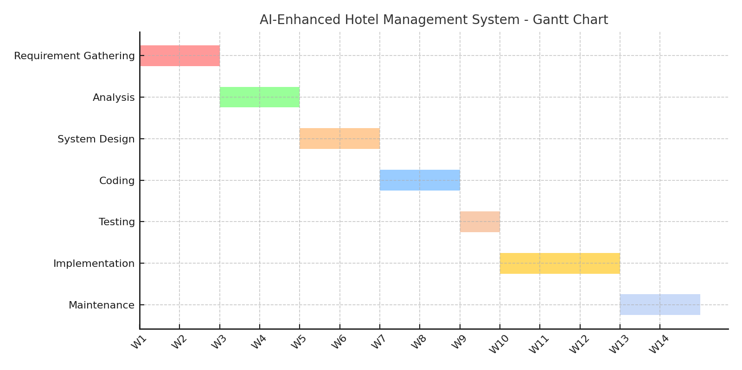

**1.1.8 RESOURCES**

This project requires a combination of human, software, and physical resources to ensure the successful design, development, testing, and deployment of the Hotel Management System.

* ***Human Resources***
* **Project Developers (2):** Responsible for design, development, testing, and deployment.
* **Supervisor:**  
  Offer academic and technical guidance, monitors project progress, and ensures compliance with academic standards.
* **Physical resources**

Item Specification

Laptop Intel Core i5 processor, 8GB RAM, 256GB SSD, for system development.

Flash Drive 16GB or more, for backing up project files and transferring data between devices.

Internet Access Required for conducting research during the development process.

* **Financial resources**

A modest budget will be required to cater for the internet access, printing, documentation, and costs during development.

* **Software resources**

| **Software Tool** | **Specification** |
| --- | --- |

* Visual Studio Code – Integrated Development Environment (IDE) for coding and debugging the website.
* Local Server Environment (XAMPP) – Used for local hosting and testing of the website before deployment.
* MySQL Database – Relational database management system for storing booking records, customer data, and service information.
* PHP, HTML, CSS, JavaScript – Core programming languages for implementing both the backend logic and the frontend user interface of the website.
* Chatbot API Integration – Enables the chatbot feature to respond to customer inquiries and assist with bookings.
* GitHub – Version control platform for storing code, tracking changes, and collaborating during development.

**1.1.9 PROJECT BUDGET**

|  |  |  |  |
| --- | --- | --- | --- |
|  |  |  |  |
| ***Item*** | ***Quantity*** | ***Unit***  ***Cost*** | ***Total Cost*** |
| ***Domain &***  ***Hosting (one month)*** | ***1*** | ***(***  ***KES***  ***)***    ***1,000*** | ***(***  ***KES***  ***)***    ***1,000*** |
| ***Internet Access***  ***(Project***  ***Duration)*** | ***one month*** | ***500*** | ***1,500*** |
| ***Software Tools (Text Editor, DB)*** | ***1 set*** | ***500*** | ***500*** |
| ***Documentation & Printing*** | ***1*** | ***500*** | ***500*** |
| ***Contingency***  ***(Transport, etc.)*** | ***-*** | ***-*** | ***500*** |
| ***Total Estimated Budget*** |  |  | ***4,000*** |

**1.2.0 DATA COLLECTION**  
Data collection is important because it helps gather accurate and reliable information about the hotel’s current booking processes, customer service challenges, and digital readiness. This ensures that the website we design addresses real needs and provides features that meet both customer and staff expectations.

**Methods of Data Collection**  
To gather information for the development of the Hotel Management System, the following methods will be used:

* **Stakeholder Interviews** – Interviews will be conducted with hotel staff and management to understand current booking workflows, menu updates, customer interaction processes, and expectations for the new website.
* **Observation** – Direct observation of hotel operations will be carried out to see how bookings, menu inquiries, and service requests are currently handled, and to identify areas where the website can improve efficiency.
* **Questionnaires** – Structured questionnaires will be given to staff and selected guests to gather feedback on service delivery, booking experiences, and desired online features.
* **Document Review** – Existing records such as booking logs, event schedules, menus, and customer feedback forms will be reviewed to identify common issues, service trends, and information gaps that the website should address.

**1.2.1FEASIBILITY STUDY**

A feasibility study is important because it checks if the proposed system can be developed successfully with the available resources. It helps us confirm that the project is technically possible, practical to use, and affordable before starting the actual development.

* ***Technical Feasibility***

The study began by evaluating the technical requirements and capabilities necessary for developing the Hotel Management System website. The project will utilize modern, open-source technologies such as PHP, JavaScript, HTML, CSS, and MySQL, all of which are compatible with standard development tools like Visual Studio Code. Chatbot integration will be achieved using readily available APIs. The developers involved have the required skills in full-stack web development, and no specialized hardware is needed beyond standard computers. These factors confirm that the system is technically feasible with the currently available resources.

* ***Operational Feasibility***

The proposed website will directly address operational challenges at Hotel Lillies, such as inefficient booking processes, lack of accessible menu and pricing information, and limited customer service availability. By allowing customers to view services, check menus and prices, and make reservations online through a responsive website and chatbot, the system will improve convenience and streamline operations. Hotel staff and management are expected to adapt easily since the system will be user-friendly and training will be provided. This demonstrates that the system is operationally feasible.

* ***Economic Feasibility***

A review of financial implications shows that the project requires minimal direct costs. Since development will be carried out using free, open-source tools, the primary expenses will involve developer time, training, and limited operational costs such as internet access and printing documentation. The long-term benefits—such as reduced booking errors, increased customer satisfaction, and a stronger online presence—will far outweigh these initial costs, making the project economically viable.

* ***Legal Feasibility***

The system will be developed in compliance with relevant legal and regulatory requirements, including data protection and privacy laws. Customer data will be securely stored, and access will be restricted to authorized personnel. By adhering to these guidelines, the system will mitigate legal risks and ensure lawful handling of sensitive data.

* ***Schedule Feasibility***

The system development process has been planned to fit within a realistic timeline of approximately 9 weeks. Using an iterative development approach, core features such as the booking module and menu display will be delivered first, followed by chatbot integration and final refinements. This staged approach ensures the project can be completed on time without compromising quality, making the schedule feasible.

# REFERENCES

Mutuku, M. W., & Otieno, F. (2020). The role of ICT in improving hotel service delivery in Nairobi County. *International Journal of Scientific and Research Publications, 10*(3), 404–410. <https://doi.org/10.29322/IJSRP.10.03.2020.p9945>

Dennis, A., Wixom, B. H., & Roth, R. M. (2021). *Systems analysis and design* (7th ed.). Wiley.

W3Schools. (2023). *PHP tutorial*. <https://www.w3schools.com/php/>

MDN Web Docs. (2023). *HTML, CSS, and JavaScript tutorials*. https://developer.mozilla.org/

Google Developers. (2023). *Responsive web design basics*. https://developers.google.com/web/fundamentals/design-and-ux/responsive

**CONTRIBUTIONS**

RACHEAL

* Statement of the problem
* Proposed solution
* Project schedule
* Gantt chart
* Objectives

STEPHEN

* Resources
* Software development methodology
* Project budget
* Data collection
* Feasibility study

#### CONCLUSION

In today’s competitive hospitality industry, efficiency, convenience, and exceptional guest experience are essential. The proposed Hotel Management System website with chatbot integration will modernize Hotel Lillies’ operations by streamlining bookings, providing instant access to menus and prices, and offering 24/7 customer support. This will minimize errors, improve service delivery, and enhance customer satisfaction, all while making daily tasks easier for hotel staff.

We are confident that this project aligns with the course’s learning outcomes and demonstrates our ability to design practical, user-focused software solutions that address real-world challenges in the hospitality sector.